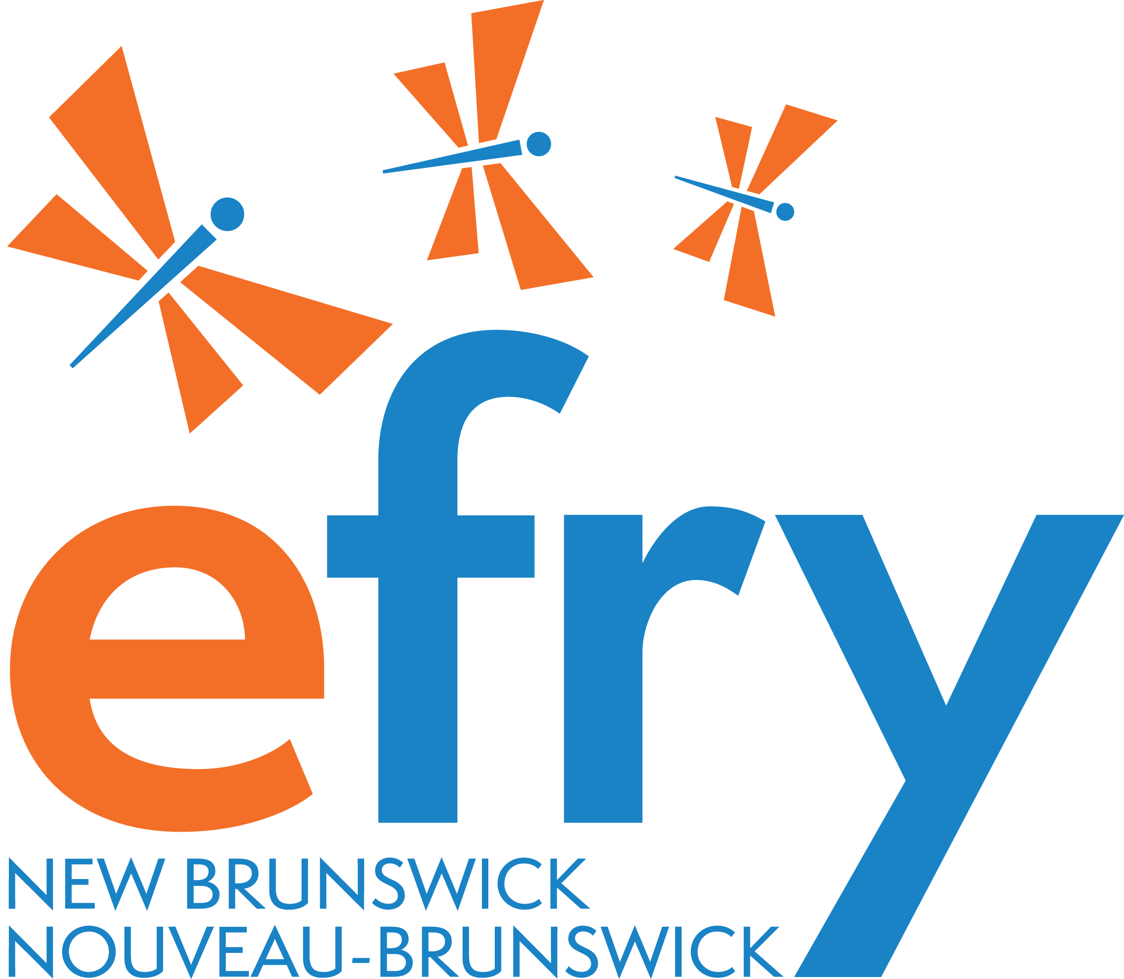
Welcome to the 2025
Elizabeth Fry New Brunswick’s Endowment Fund

At EFryNB, we're committed to supporting dreams of New Brunswick women and gender-diverse individuals impacted by criminalization. Our bursary funds can help you with education—books, technology, or materials; or with employment—certification courses, work attire, or necessary equipment. You are invited to apply for our 2025 Bursary.

Applying is easy! 3 Ways to fill out the application!!
- on paper or
- through a video call, or
- through an audio tape.
Our EFryNB team is here to assist you every step of the way.

Don't forget to include a letter of reference from a non-family member who knows about your journey. This letter should include their contact details for verification purposes.

Application Review: Our dedicated EFryNB Board members carefully review all applications. We consider both financial need and the strength of your education or employment plan outlined in your application. If you're successful, we'll reach out to you directly, and you'll receive your bursary via cheque or electronic transfer.

Mark your calendars!
Applications must be submitted to Elizabeth Fry New Brunswick, 75 Adelaide Street, Saint John NB E2K 1W4 or efry@nb.aibn.com no later than May 2, 2025.
We'll review all submissions by June 6th, 2025
Successful applicants will be notified by June 12, 2025.

Questions? We're here to help! Reach out to EFryNB at 506-635-8851 or efry@nb.aibn.com.
Thank you for considering the Elizabeth Fry New Brunswick's Endowment Fund. We're excited to support you on your journey!

EFryNB Endowment Fund 2025 Application Form

Date:
Name:
EFryNB contact support person (if applicable):
Name of organization recommending you (if applicable)
Mailing address:
Email address:
Phone number:
- Tell us a bit about yourself: (350 words max)

- Are you incarcerated or have you been incarcerated in the past? Or
Have you been impacted by criminalization? Please Explain.

- What are your educational or employment goals? (350 words max)

- What training and skills development and/orx certification have you already completed? (350 words max)

- Have you faced barriers to achieving your educational or employment goals? Please share that experience to your own level of comfort. (350 words max)

- How will you use this funding to support your educational or employment goals? (350 words max)

- Please describe any involvement you have had with your EFryNB team, programs or support services. (350 words max)

- Have you received any other/additional bursaries or educational support towards your educational or employment goals? If yes, what will that be applied to in your goal plan?

- If you do receive the bursary funding for this year, are there other ways you feel EFryNB may be able to assist in obtaining your educational or employment goals (writing resume, interview preparation, connection to other services, record suspension processes)? (350 words max)

- Is there anything else you would like to share with us?

Thank you for applying and sharing your journey with EFryNB. We offer each applicant the best of luck moving forward with your goals. We encourage anyone who was not selected to apply again for future assistance with their educational and employment goals.

